**Dashboard 1 Requirements**

* Take any image regarding healthcare and drag it to the dashboard.
* Using Text object, give it a meaningful name based on your data analysis of the file.

Answer 1:

Healthcare Data

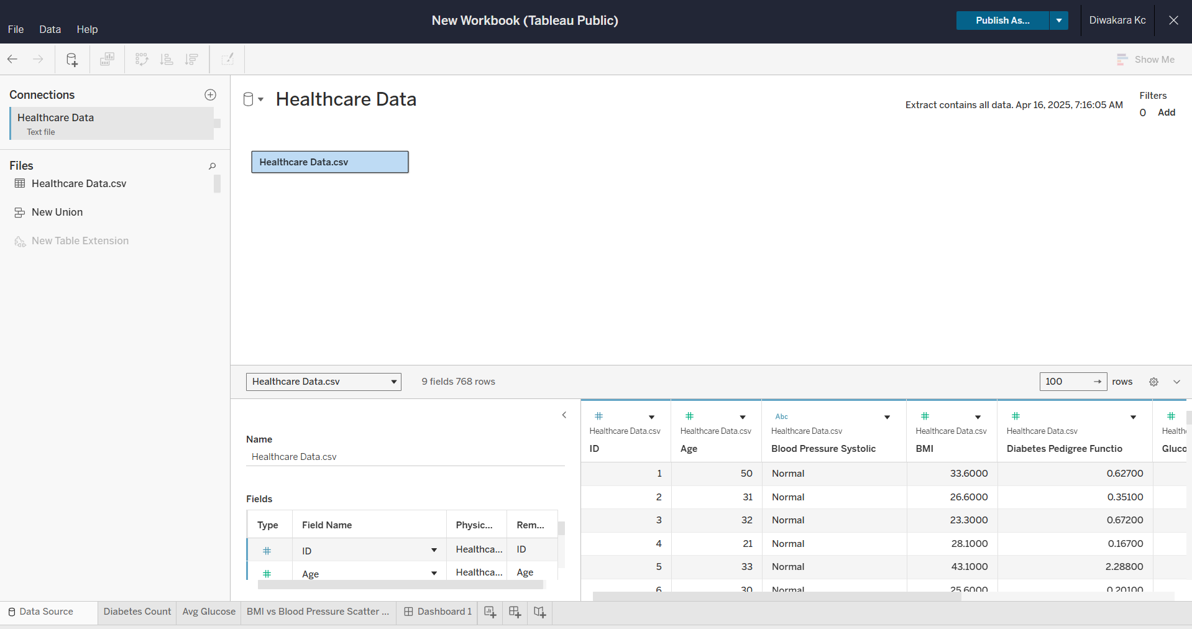

Diabetes count

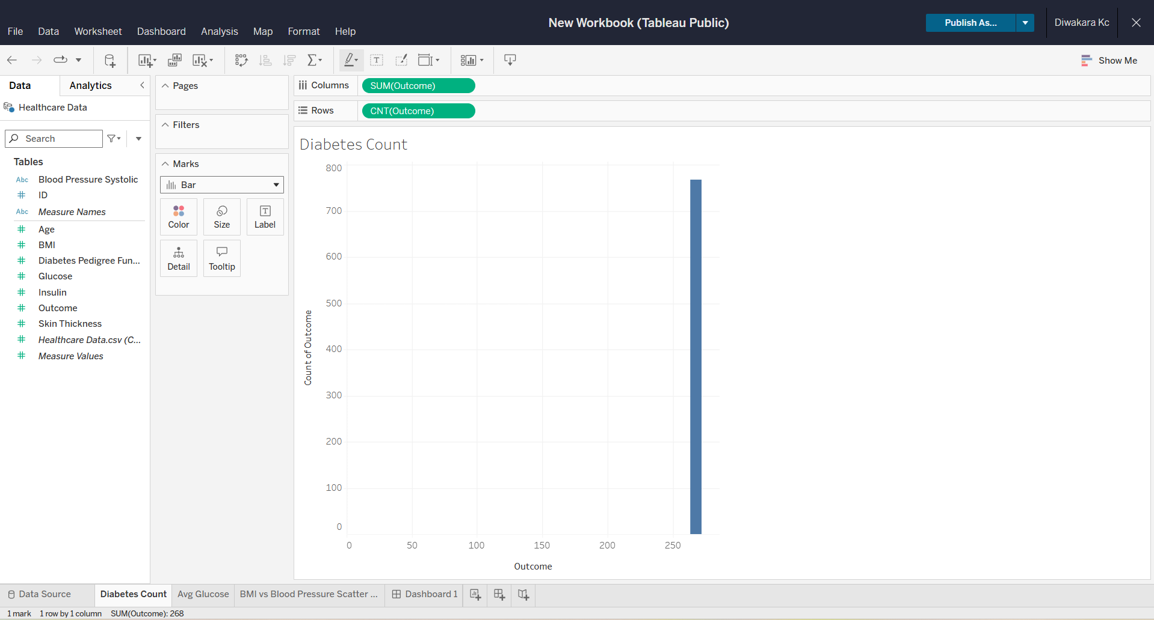

Average glucose

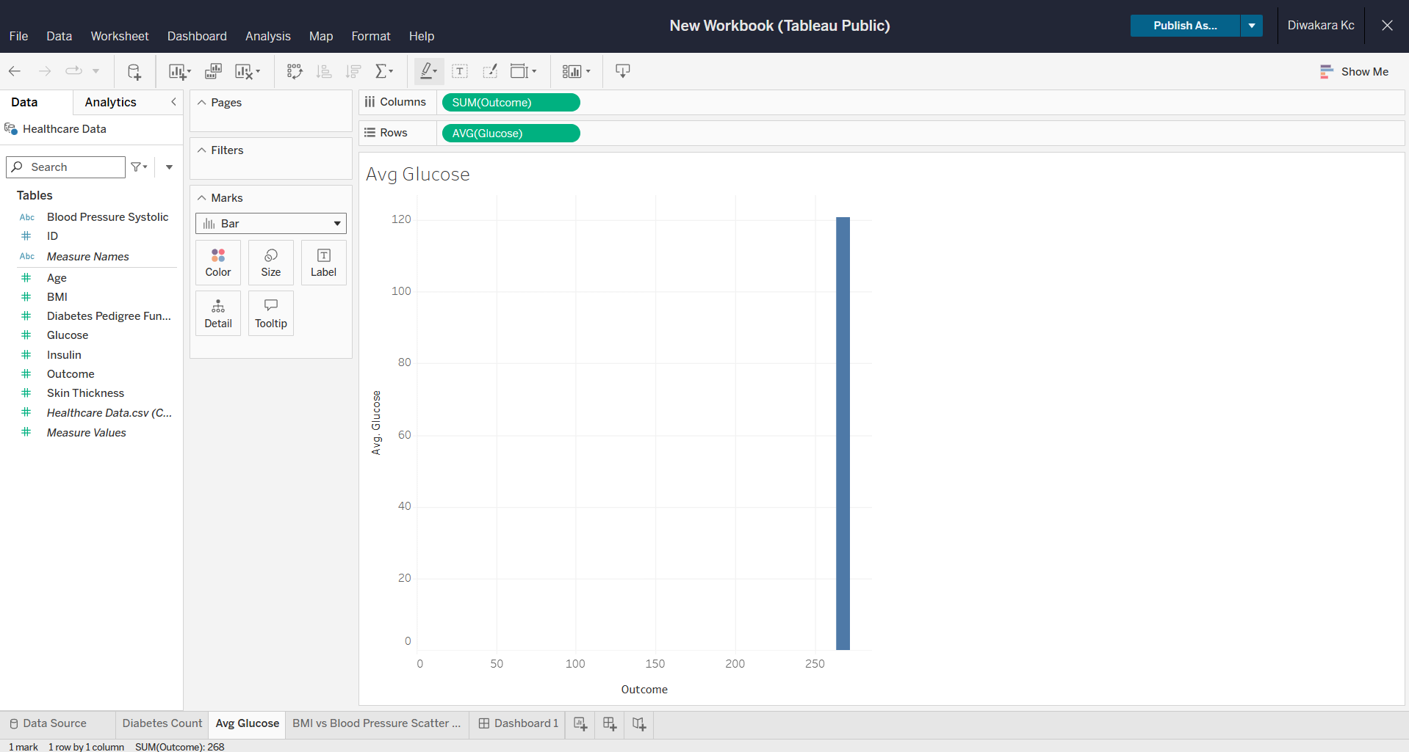

BMI vs Blood pressure scatter plot

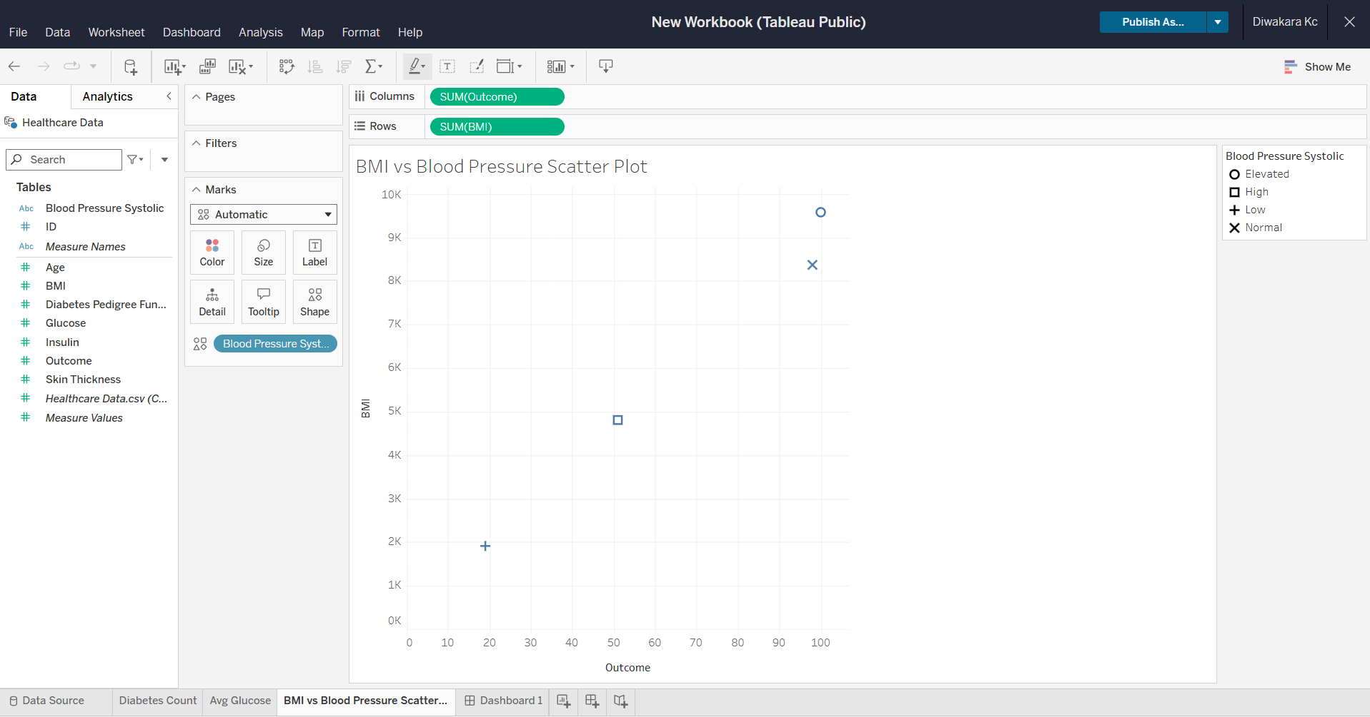

Dashboard 1

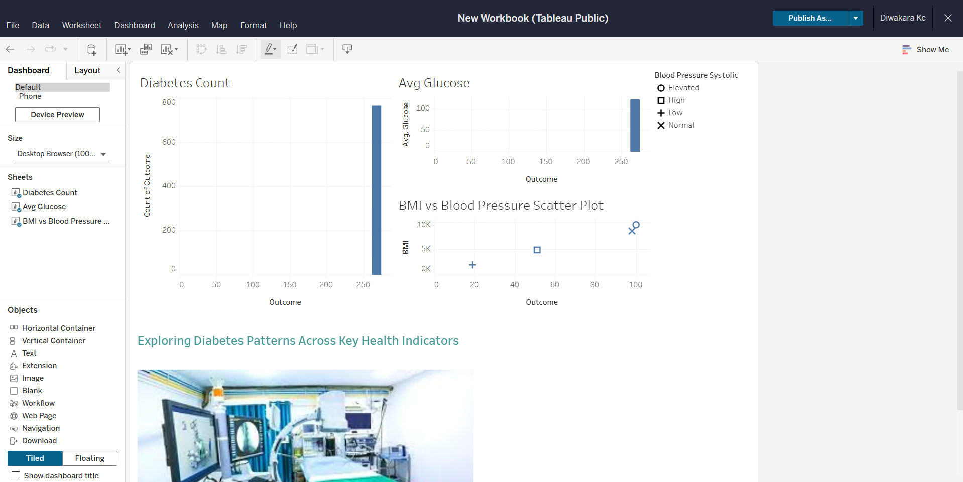

**Dashboard 2 Requirements**  
  
View 1: Diabetic/Non-diabetic using Shapes

* Use Shapes to show the distribution between diabetic/non-diabetic patients.
* Using the “Outcome” field, write a calculated field by classifying 1 as Diabetic patients and 0 as Non-diabetic patients.
* Show the percent distribution as shown in the expected view.
* Use the color of your choice to differentiate Diabetic Vs. Non-diabetic patients.
* Tooltip should display patient count.
* You can use shapes of your choice or use the below one.
* Format as per your choice.
* Enable Action filters.

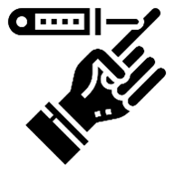View 2: Patient summary by Blood Pressure category

* Use any shape of your choice to show patient summary by blood pressure category.
* Show the Patient count and BP category type on the labels.
* Use the color of your choice to differentiate Diabetic Vs. Non-diabetic patients.
* Format as per your choice.
* Enable Action filters.

View 3: Create a Histogram to show Body Mass Index (BMI) by Age Groups.

* Since we need to build a Histogram, using the Age field, let’s create bins using size 5.
* In a Histogram, you will have bins 20, 25, 30, etc. So, the bin size 20 will include age groups between 20-24, and size 25 will include 25-29. So, to be clear let’s edit the aliases of the age groups as it might confuse the users. So, let’s use aliases as shown below or you can create a calculated field for the Age groups.
* 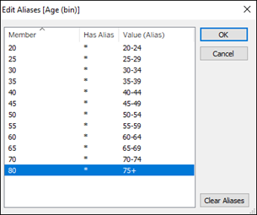In case, there are missing values, hide them.
* Display the average BMI value on top of each bar and round it to 2 decimals.
* Use the average BMI to color the palette using shades of Red.

View 4: Single Bar showing percent distribution of patients by BMI type

* Create a calculated field to classify Patients by BMI types.
  + [BMI]<18.5= 'Underweight'
  + [BMI]>=18.5 and [BMI]<25 ='Healthy Weight'
  + [BMI]>=25 and [BMI]<30 = 'Overweight'
  + [BMI]>=30 ='Obese'
* Enable Action filters.

**Expected Final View**  
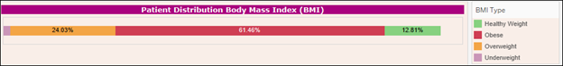  
View 5: Bar Chart showing Patient break down by Blood Pressure and Diabetes

* Create a calculated field to only highlight Diabetic patients with High and Low blood pressures.

View 6: Build a HEAT MAP showing several health factors by Age group  
  
**Story Requirements**

* Story Name: Healthcare
* Story Title: Healthcare Summary Report
* Story description: Add one if you wish to
* Story size:  Custom Size (best choice)
* Story Layout: Navigator style should be set to Numbers
* Story Point 1: Should contain Dashboard 1
* Story Point 2: Should contain Dashboard 2
* Story Point 3: Should contain Heat Map Worksheet

Answer 2:

Diabetic distribution

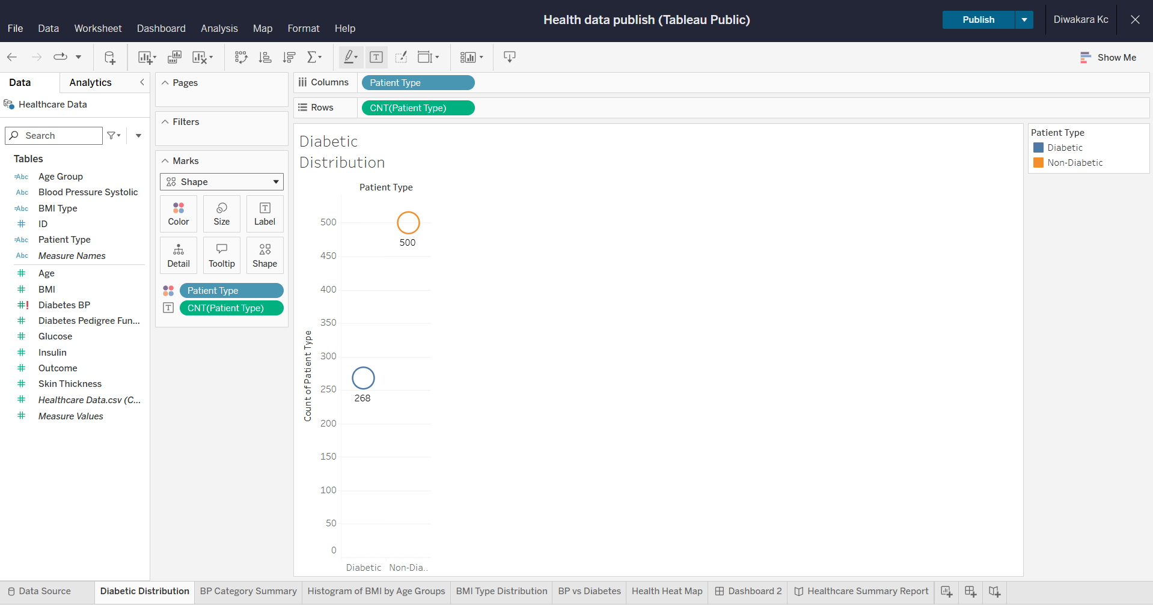

BP category summary

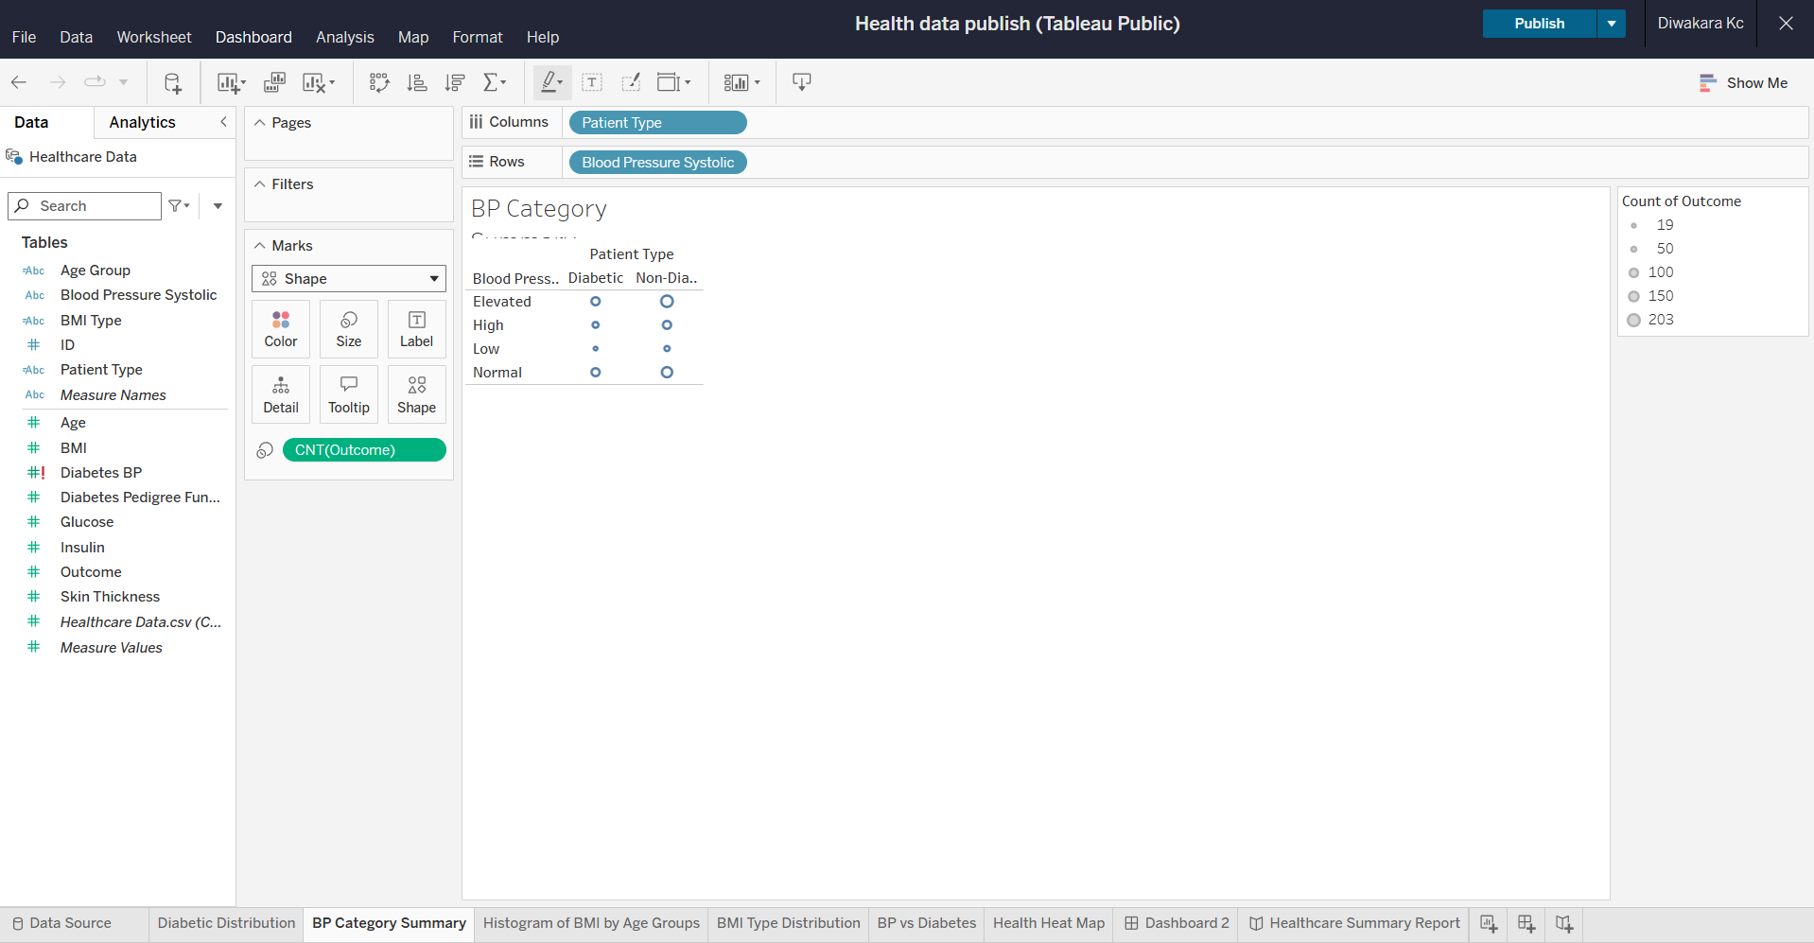

Histogram of BMI

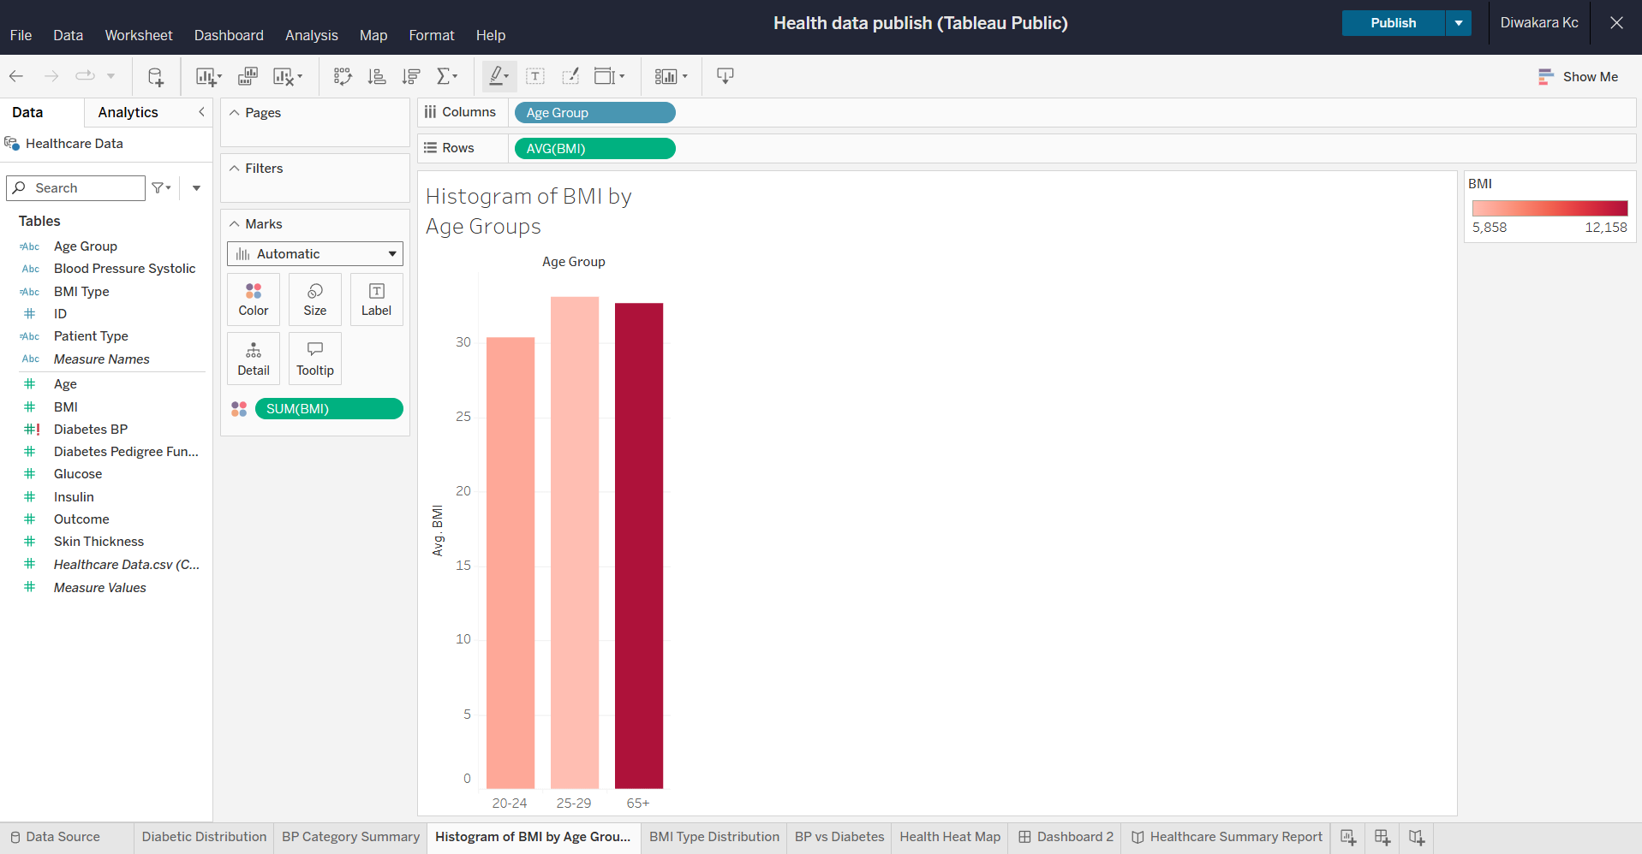

BMI Type distribution

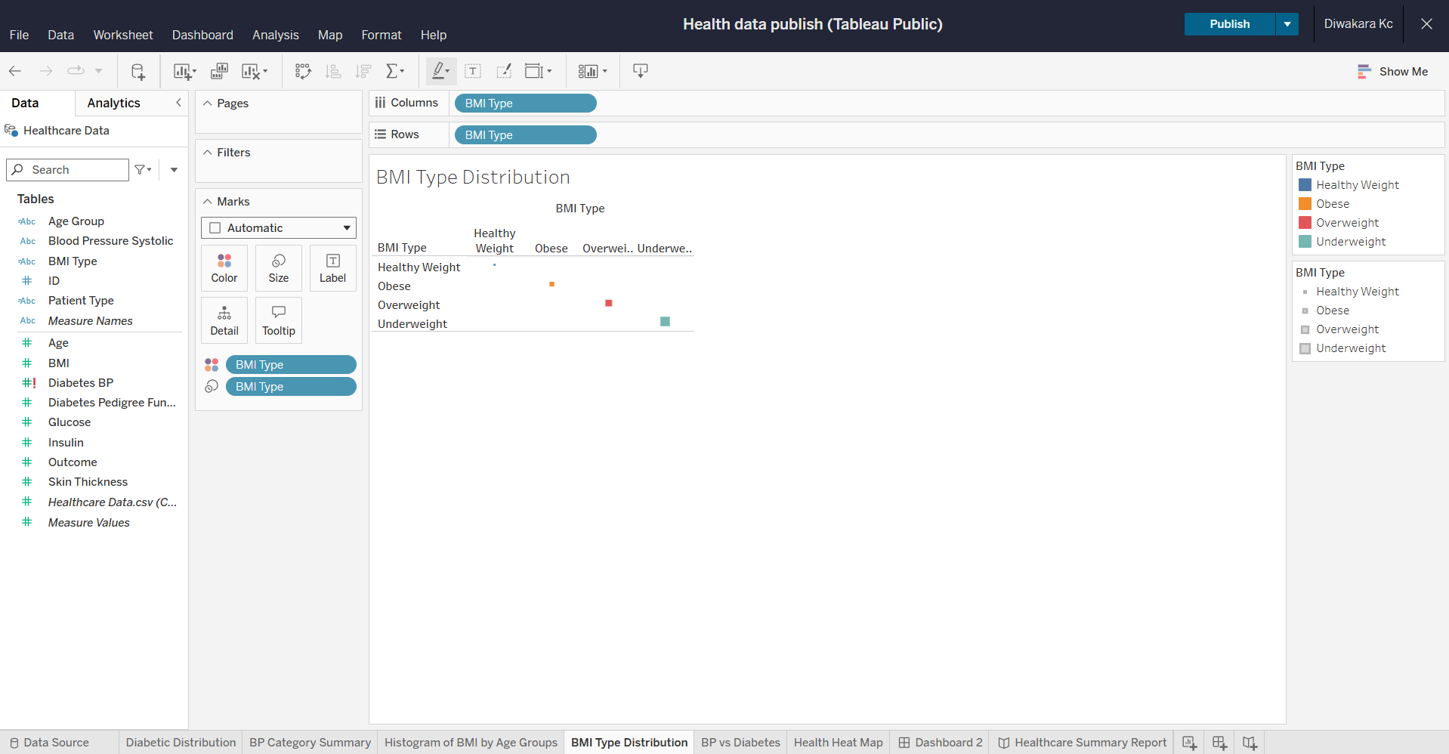

BP vs Diabetes

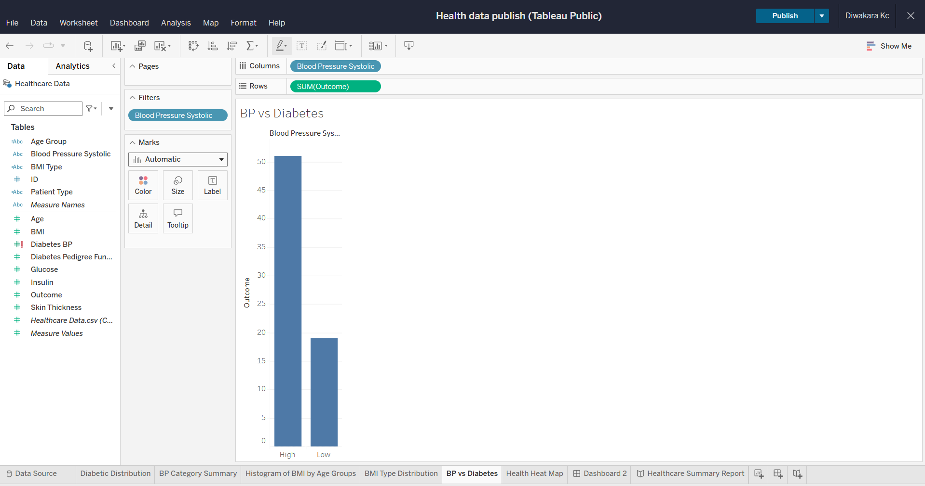



Dashboard 2

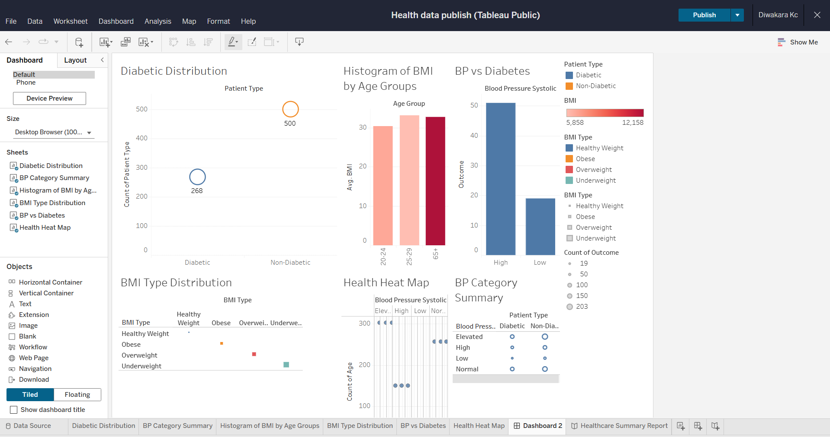

Healthcare summary report story

